**Biology practical Session 2 Food tests enzymes and digestion**

**Contents**

Required knowledge and potential misconceptions …………………………….p2

BEST diagnostic activity………………………………………………………..p3

BEST retrieval activity …………………………………………………………p4

Practical 1 investigating the quantity of protein in powdered milk…………….p5

Food tests ………………………………………………………………………p7

Exam questions…………………………………………………………………p9

Exam question mark scheme……………………………………………………p12

Examiner reports ……………………………………………………………….p14

Final reflections and targets…………………………………………………….p15

# 

# Required knowledge and potential misconceptions

The study of enzymes is a biochemistry topic that BEST places under the Big theme of the cellular basis of life. It is helpful to ensure the students have the following foundational knowledge before moving onto enzymes.

|  |  |  |  |
| --- | --- | --- | --- |
| Required knowledge from KS3 | Potential misconceptions | Required knowledge from KS4 | Potential misconceptions |
| The body needs a balanced diet with carbohydrates, lipids, proteins, vitamins, minerals, dietary fibre and water, for its cells’ energy, growth and maintenance. Organs of the digestive system are adapted to break large food molecules into small ones which can travel in the blood to cells and are used for life processes | Students have limited understanding of the role of digestion to get the vitamins and minerals that are “good for you from food". Pupils can incorrectly believe that digestion (rather than cellular respiration) is the process that releases useful energy from food | Students should understand the human digestive system in more detail the role of enzymes and how enzyme activity is linked to metabolism. | Students often incorrectly believe your metabolism is fixed or that lifestyle choices will have limited or no impact on your base metabolic rate. |

**BEST diagnostic question**

**What happens to the food we eat?**

1. What happens to the food we eat?

|  |  |
| --- | --- |
| **A** | All of it stays in the body. |
| **B** | Some of it stays in the body and some of it leaves the body. |
| **C** | All of it leaves the body. |

1. How would you explain your answer to question 1?

|  |  |
| --- | --- |
| **A** | Goodness is taken out of the food, then we get rid of the rest. |
| **B** | The food is digested and nutrients are absorbed, then we get rid of the rest. |
| **C** | The food is broken down and turned into poo, which we get rid of. |
| **D** | The food is used to make us grow bigger and taller. |

**BEST Response activity A model of digestion**

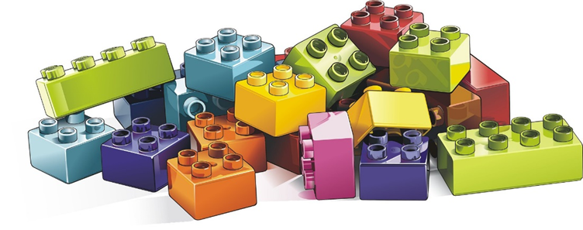

Imagine that:

* the brick models you have been given are pieces of food in the digestive tract
* the piece of card is the wall of the digestive tract
* you are a digestive enzyme in the digestive tract.

**To talk about in your group**

1. Which types of food can be absorbed through the wall of the digestive tract into the body?
2. Which types of food need to be digested by an enzyme before they can be absorbed?
3. Which types of food cannot be absorbed, and why? How would we model thse using the Lego bricks?

**Activity 1 Quantitative tests: protein content of powdered milk**

C:\Users\20337\AppData\Local\Microsoft\Windows\INetCache\Content.MSO\B4BD459C.tmp

SAFETY: Wear eye protection when handling the Neutrase™ solution. Powdered enzymes can cause irritation by inhalation and sensitisation – so work in a fume cupboard if making up solutions from powder, and clear up spills of solutions immediately.

**Investigation**

**a** Set out 7 test tubes and label them 1%, 2%, 3%, 4%, 5%, X and Y.

**b** To each tube, add 10 cm3 of the appropriate milk powder solution.

**c** Add 5 cm3 of enzyme solution to the first tube (1%). Squirting it in can help to make the mixing rapid, but may result in splashing. Shake to mix thoroughly, and start the stopclock.

**d** Record the time it takes for the solution to become clear. It may be easier to determine the end with a colorimeter. You could mark a cross on a piece of white paper, view the cross through the mixture, and record the time it takes for the cross to become visible.

**e** Repeat with the other concentrations of milk powder, both known and unknown.

**f** Identify any anomalous results, and repeat if time. If repeating, use clean glassware, as it is difficult to rinse the enzyme fully from the tubes. If clean glassware is not available, add the enzyme to the tube first and start the clock on adding the milk.

**g** Add each group’s results to the class set and discuss

Student analysis:

Plot two graphs of time taken for the solution to clear against concentration for the known concentrations. On one graph, plot your own results, and on the other plot the class average as calculated after discussion.

 Use these calibration curves to estimate the concentration of protein in solutions X and Y.

Collate estimates from each group to a set of class data, and discuss the variations.

**Working scientifically skill analysing or evaluating data**

Below is a set of data collected by a group of BTEC students

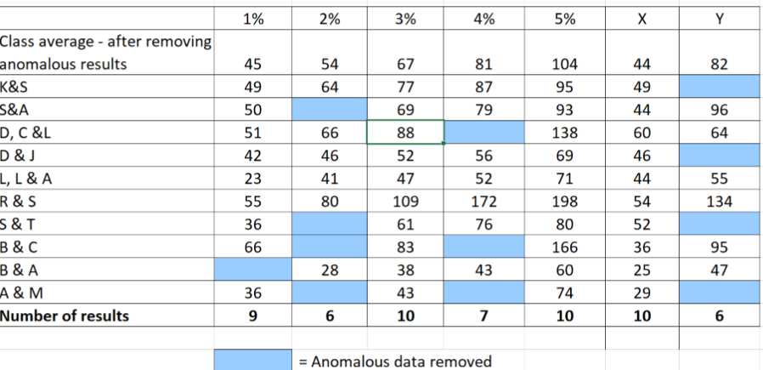

How do they compare to your results?

How do the number of anomylous results compare?

How do your conclusions about the identity of X and Y compare to the conclusions you would make based on the data set below?

How would you improve the experimental procedure to ensure results are more accurate and reliable ?( Ensure you are clear with the different definitions of reliable and accurate).

Additional notes section

**Practical 2 Food tests Qualitative tests for different types of food groups.**

Use qualitative reagents to test for a range of carbohydrates, lipids and

proteins. To include: Benedict’s test for sugars, Iodine test for starch and Biuret

reagent for protein.

In this practical you will:

use qualitative reagents to test for the presence of carbohydrates, lipids and proteins in a range of

foods.

Test for carbohydrates

The Benedict’s test for sugars

Apparatus

• food sample

• a test tubes

• Benedict’s solution

• traditional water bath to include Bunsen burner use

• thermometer

• pipettes.

Method

1. Set up your traditional water bath set up using a Bunsen burner.

2. Put some of the food sample into a test tube.

3. Add a few drops of Benedict’s solution to the sample in the test tube.

4. Put the test tube in the water bath at a minimum of 80 °C for about 5 minutes.

5. Note down any colour change in your table of results.

The Iodine test for starch

Apparatus

• food sample

• a test tubes

• iodine solution

• pipettes.

Method

1. Put some of the food sample into a test tube.

2. Add a few drops of Iodine solution.

3. Note down any colour change in your table of results.

Test for lipids

Apparatus

• food sample

• a test tubes

• ethanol

• distilled water.

Method

1. Put some of the food sample into a test tube.

2. Add a few drops of distilled water.

3. Add a few drops of ethanol.

Care: Ethanol is highly flammable. Keep the solution away from any flames.

4. Shake the solution gently.

5. Note what you see in your table of results.

Test for protein

Apparatus

• a test tubes

• a 10 cm3measuring cylinder

• Biuret solution A and Biuret solution B.

Method

1. Put some of the food sample into a test tube.

2. Add 1 cm3 of Biuret solution A and 1 cm3 of Biuret solution B to the test tube.

Care: Biuret solution contains copper sulphate, which is poisonous, and sodium

hydroxide, which is corrosive. Handle the solution with care. Wash immediately if you spill it on your skin and wipe up any spills.

3. Shake the tube gently to mix.

4. Note any colour change in your table of results.

**Working scientifically skill recording data**

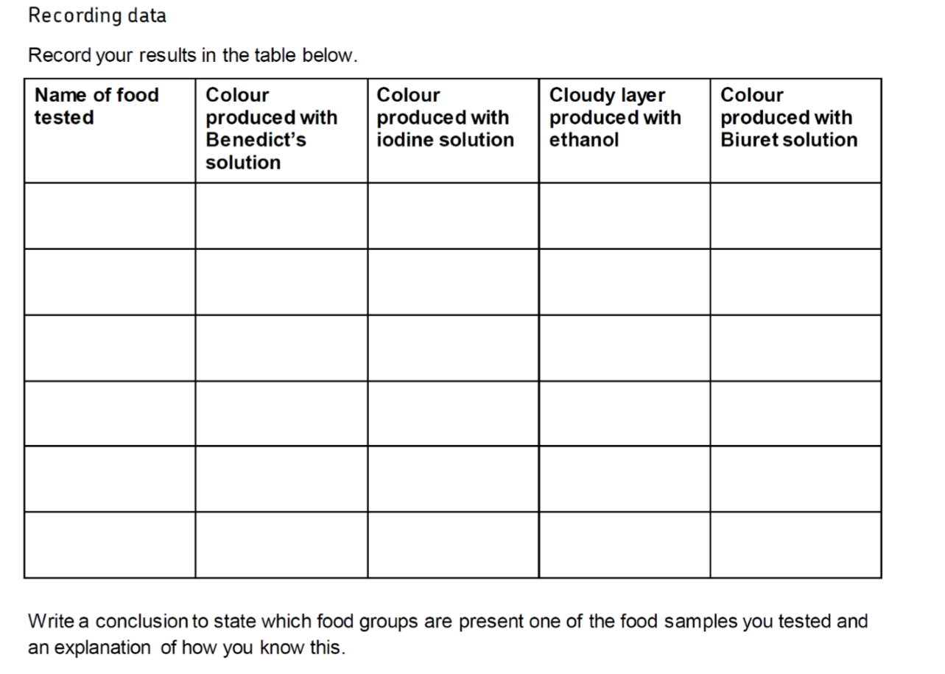

**Exemplar exam questions**

**Q1.**

The diagram below shows the human digestive system.

(a)  Label organs **A**, **B** and **C**.

**(3)**

(b)  Complete the sentences.

Choose the answers from the box.

|  |  |  |  |
| --- | --- | --- | --- |
| **catalyse** | **denatured** | **digest** | **energise** |
| **excreted** | **ingested** | **insoluble** | **soluble** |

Digestion is the process of breaking down large food molecules into smaller

molecules that are ____________________________ .

Enzymes help to break down food because they ____________________________

chemical reactions.

If the temperature of an enzyme gets too high, the enzyme is _________________ .

**(3)**

(c)  Protease is an enzyme.

Protease breaks down protein.

What is protein broken down into?

Tick **one** box.

|  |  |
| --- | --- |
| Amino acids |  |
| Fatty acids |  |
| Glucose |  |
| Glycerol |  |

**(1)**

(d)  Why is protein needed by the body?

___________________________________________________________________

___________________________________________________________________

**(1)**

(e)  Which organ in the human digestive system produces protease?

Tick **one** box.

|  |  |
| --- | --- |
| Gall bladder |  |
| Large intestine |  |
| Liver |  |
| Stomach |  |

**(1)**

(f)   Describe how you would test a sample of food to show it contains protein.

Give the reason for any safety precautions you would take.

___________________________________________________________________

___________________________________________________________________

___________________________________________________________________

___________________________________________________________________

___________________________________________________________________

___________________________________________________________________

___________________________________________________________________

___________________________________________________________________

___________________________________________________________________

___________________________________________________________________

**(4)**

(g)  Complete the sentence.

Choose the answer from the box.

|  |  |  |  |
| --- | --- | --- | --- |
| **fat** | **fibre** | **minerals** | **vitamins** |

Obesity can be caused by a diet high in _______________________ .

**(1)**

(h)  Complete the sentence.

Choose the answer from the box.

|  |  |  |
| --- | --- | --- |
| **skin cancer** | **type 1 diabetes** | **type 2 diabetes** |

Obesity is a risk factor for _______________________ .

**(1)**

**(Total 15 marks)**

**Q2.**

**Table 1** shows information about some food components in cow’s milk.

**Table 1**

|  |  |  |
| --- | --- | --- |
|  | **Value per 500 cm3** | **Recommended Daily Allowance (RDA) for a typical adult** |
| Energy in kJ | 1046 | 8700 |
| Fat in g | 8.4 | 70.0 |
| Salt in g | 0.5 | 6.0 |
| Calcium in mg | 605 | 1000 |
| Vitamin B-12 in µg | 4.5 | 2.4 |

(a)  How much **more** milk would a typical adult have to drink to get their RDA for calcium compared with the amount of milk needed to get their RDA for vitamin B-12?

___________________________________________________________________

___________________________________________________________________

___________________________________________________________________

___________________________________________________________________

___________________________________________________________________

___________________________________________________________________

Volume of milk = ______________________ cm3

**(3)**

(b)  Describe how a student could test cow’s milk to show whether it contains protein and different types of carbohydrate.

___________________________________________________________________

___________________________________________________________________

___________________________________________________________________

___________________________________________________________________

___________________________________________________________________

___________________________________________________________________

___________________________________________________________________

___________________________________________________________________

___________________________________________________________________

___________________________________________________________________

___________________________________________________________________

___________________________________________________________________

___________________________________________________________________

___________________________________________________________________

___________________________________________________________________

___________________________________________________________________

___________________________________________________________________

___________________________________________________________________

**(6)**

A scientist investigated the effect of bile on the breakdown of fat in a sample of milk.

The scientist used an indicator that is colourless in solutions with a pH lower than 10, and pink in solutions with a pH above 10.

This is the method used.

1.   Add 1 drop of bile to a test tube and one drop of water to a second test tube.

2.   Add the following to each test tube:

•   5 cm3 of milk

•   7 cm3 of sodium carbonate solution (to make the solution above pH 10)

•   5 drops of the indicator

•   1 cm3 of lipase.

3.   Time how long it takes for the indicator in the solutions to become colourless.

The results are shown in **Table 2**.

**Table 2**

|  |  |
| --- | --- |
|  | **Time taken for the indicator to become colourless in seconds** |
| **Solution with bile** | 65 |
| **Solution without bile** | 143 |

(c)  Explain why the indicator in both tubes became colourless.

___________________________________________________________________

___________________________________________________________________

___________________________________________________________________

___________________________________________________________________

___________________________________________________________________

___________________________________________________________________

**(3)**

(d)  Give the reason why the measurement of the time taken for the indicator to become colourless might be inaccurate.

___________________________________________________________________

___________________________________________________________________

**(1)**

(e)  Explain the difference in the results for the two test tubes in **Table 2**.

___________________________________________________________________

___________________________________________________________________

___________________________________________________________________

___________________________________________________________________

___________________________________________________________________

___________________________________________________________________

**(3)**

**(Total 16 marks)**

Mark schemes

**Q1.**

(a)  (A) stomach

**1**

(B) small intestine

*allow ileum*

*ignore intestine unqualified*

**1**

(C) liver

**1**

(b)  soluble

**1**

catalyse

**1**

denatured

**1**

*this order only*

(c)  amino acids

**1**

(d)  any **one** from:

•   for growth

*allow for enzymes / hormones / antibodies*

•   for repair / replacement (of cells / tissues / organs)

*allow to strengthen bones*

*ignore for energy*

**1**

(e)  stomach

**1**

(f)   **Level 2:** Scientifically relevant facts, events or processes are identified and given in detail to form an accurate account.

**3−4**

**Level 1:** Facts, events or processes are identified and simply stated but their relevance is not clear.

**1−2**

**No relevant content**

**0**

**Indicative content**

•   grinding up the food

•   add Biuret reagent (allow CuSO4 and NaOH) to food (sample)

•   protein turns solution (from blue) to purple / lilac

•   wear goggles to protect eyes

•   clean up spills immediately

•   Biuret / NaOH is an irritant / corrosive / poisonous

for **level 2** a reference to Biuret, a positive result and reason for a safety precaution is required

(g)  fat

**1**

(h)  type 2 diabetes

**1**

**[15]**

**Q2.**

(a)  (for calcium)

*allow any correct rounding to minimum 3 significant figures*

*allow alternative route with correct rounding*

**1**

(for vitamin B-12)

*allow alternative route with correct rounding*

**1**

560 / 559.8 / 559.78 / 559 (cm3)

*allow only correct answer based on values given for vitamin B-12 and calcium*

**1**

*an answer of 560 / 559.8 / 559.78 / 559 (cm3) scores* ***3*** *marks*

*an incorrect answer for one step does not prevent allocation of marks for subsequent steps*

(b)  **Level 2:** Scientifically relevant facts, events or processes are identified and given in detail to form an accurate account.

**4−6**

**Level 1:** Facts, events or processes are identified and simply stated but their relevance is not clear.

**1−3**

**No relevant content**

**0**

**Indicative content**

•   Biuret reagent (allow CuSO4 and NaOH) tests for protein

•   add Biuret reagent to milk

•   solution will turn (from blue) to lilac if positive

•   iodine solution tests for starch (ignore iodine unqualified)

•   add iodine solution to milk

•   solution will turn (from orange / brown) to blue / black if positive

•   Benedict’s reagent tests for sugars

•   add Benedict’s reagent to milk and boil / heat (allow any temperature above 60 °C)

•   solution will turn (from blue) to (brick) red / brown / orange / yellow / green if positive

for **level 2**, reference to all three food tests is required

(c)  lipase breaks down fat into fatty acids (and glycerol)

*do* ***not*** *accept if ‘glycerol’ is contradicted*

**1**

(and) fatty acids lower the pH

**1**

(and when) fatty acids cause the pH to be below 10 (the indicator becomes colourless)

**1**

(d)  observation of colour change is subjective / based on opinion

*ignore human error unqualified*

*ignore experimental error or examples of this*

**1**

(e)  bile emulsifies fats

*allow a correct description of emulsification (i.e. breaks fat from large droplets into smaller droplets)*

*do* ***not*** *accept a description of chemical breakdown*

**1**

creates a larger surface area (of fat)

**1**

(so) lipase can break down fat (to produce fatty acids) more quickly / effectively

*allow fatty acids produced by action of lipase more quickly*

**1**

**[16]**

Examiner reports

**Q1.**

(a)  46% of students were able to identify all three parts of the digestive system. A number of organs unrelated to this system were named, including lungs and kidneys.

(b)  73% of students achieved at least two marks here.

(c)  70% of students had learned that proteins are broken down into amino acids. Glucose was the most commonly selected of the distractors.

(d)  Students referred to growth or repair here. Although biologically incorrect, ‘for repair of cells’ was allowed at this level. References to health, body-building or strengthening muscles were all considered too vague to gain credit. Although protein can be used to provide energy, this is not why the body needs protein, so this idea was ignored.

(e)  38% of students identified the stomach as the site of protease production. Both the large intestine and the liver proved to be popular distractors and the gall bladder was also selected by a significant minority of students.

(f)  Many students seemed to be unfamiliar with the test for proteins and a lot of answers referred to iodine or Benedict’s solution instead of Biuret reagent. More were aware that a purple colour indicated a positive result, although credit was not given if an incorrect colour was linked as an alternative so e.g. ‘purple or black’ was considered to be confusion with iodine solution.

Spelling of ‘Biuret’ was immensely varied but as long as the version used approached a phonetic equivalent it was acceptable.

For a student’s answer to match a level 2 response it had to acknowledge all aspects of the question and, therefore, include a reference to Biuret, the correct positive outcome and a reason for a safety procedure.

Students sometimes failed to access level 2 because of insufficient attention to the safety aspect. An answer that simply said goggles should be worn was not enough as no clear reason for this e.g. ‘to protect the eyes’ was offered. Neither wear a lab coat nor tie hair back were considered relevant safety measures in this context.

Relatively few students picked up on the fact that Biuret is an irritant, is corrosive or is toxic. An answer worthy of the higher mark within level 2 may have given this detail or may have added some further description such as a reference to grinding up food before testing.

Level 1 responses gave only part of the picture e.g. no mention of Biuret but the correct positive result and a suitable reference to safety. A significant number of students did not attempt this question.

(g)  94% of students knew that a diet high in fat is the cause of obesity.

(h)  76% of students correctly identified type 2 diabetes, with most of the others selecting type 1 diabetes.

**Q2.**

(a)  The most common reason why students who took the right route but did not achieve full marks for this question was incorrect rounding part way through the calculation, e.g., a value of 266.6 being used rather than 266.7. It was common for students to write down a long string of decimal places in their calculations.

(b)  Generally this question was well answered with 48% achieving three or more marks. Most students made good attempts to gain full marks and often wrote at length. The test for protein was well known by the majority of students. However, the need to describe both the starch test and the test for glucose was not recognised by a significant number of students, who often gave only the former.

In the starch test, students needed to refer to iodine solution, rather than just iodine. When describing the test for sugars, the need for heat was often omitted, with some students only referring to a water bath, rather than a hot water bath. Some students confused the colour changes for positive results.

(c)  Those students who started their answer with the idea that the lipase was breaking down fat into fatty acids (and glycerol) often went on to achieve full marks. However, many students attempted to describe their answers in terms of the neutralising effect of bile and thus resulted in no marks.

(d)  Many students gave the correct reason, referring to the subjective nature of the values. However, a significant number suggested that the measurement of time might be inaccurate due to a human error or a stop clock that was not accurate.

(e)  There were a number of students who confused the answers with that for question 07.3. It was not uncommon for students to suggest that bile is an enzyme or described their answers in terms of the pH of bile or its effects on pH of the mixture.

Those students who recognised that the difference was due to emulsification of the fat in milk often went on to describe the consequence on surface area. However, the final mark was often poorly explained or lacked detail, with students often suggesting that the bile, rather than the lipase, broke down the fat more quickly.

Reflective activity/plenary

What subject knowledge do you need to refine in the topic of digestion,metabolism and food tests?

Where did you not achieve full marks in the exam Q’s. What items did you miss out?

How will you need to expand beyond the “required practical” in your teaching to ensure pupils have detailed knowledge required?